**Project Design Phase**

**Solution Architecture**

|  |  |
| --- | --- |
| Date | 27 june 2025 |
| Team ID | LTVIP2025TMID31456 |
| Project Name | Health ai: Intelligent healthcare assistant using ibm granite |
| Maximum Marks | 4 Marks |

**Solution Architecture:**

* Alignment with Business Goals: A well-defined solution architecture ensures that the AI assistant is built to address specific business needs and deliver measurable value. It bridges the gap between technical capabilities and organizational objectives.

* Scalability and Performance: AI assistants, particularly those powered by large language models like Granite, need to be scalable to handle varying user loads and perform efficiently. Solution architecture dictates how the system will scale, manage resources, and maintain low latency.

* Reliability and Robustness: A solid architecture minimizes points of failure, incorporates error handling, and ensures the AI assistant remains available and functional, even under unexpected conditions. This is crucial for maintaining user trust and satisfaction.

* Security and Compliance: AI systems often handle sensitive data. Solution architecture defines data privacy measures, access controls, and compliance with relevant regulations (e.g., GDPR, HIPAA), which is especially important for enterprise-grade solutions. IBM Granite models, for instance, are trained on license-permissible data and adhere to IBM’s AI Ethics principles, but the overall solution architecture needs to uphold these standards.

* Maintainability and Extensibility: A well-architected solution is easier to maintain, debug, and update. It also allows for future enhancements and the integration of new features or technologies without a complete overhaul.

**Example - Solution Architecture Diagram:**

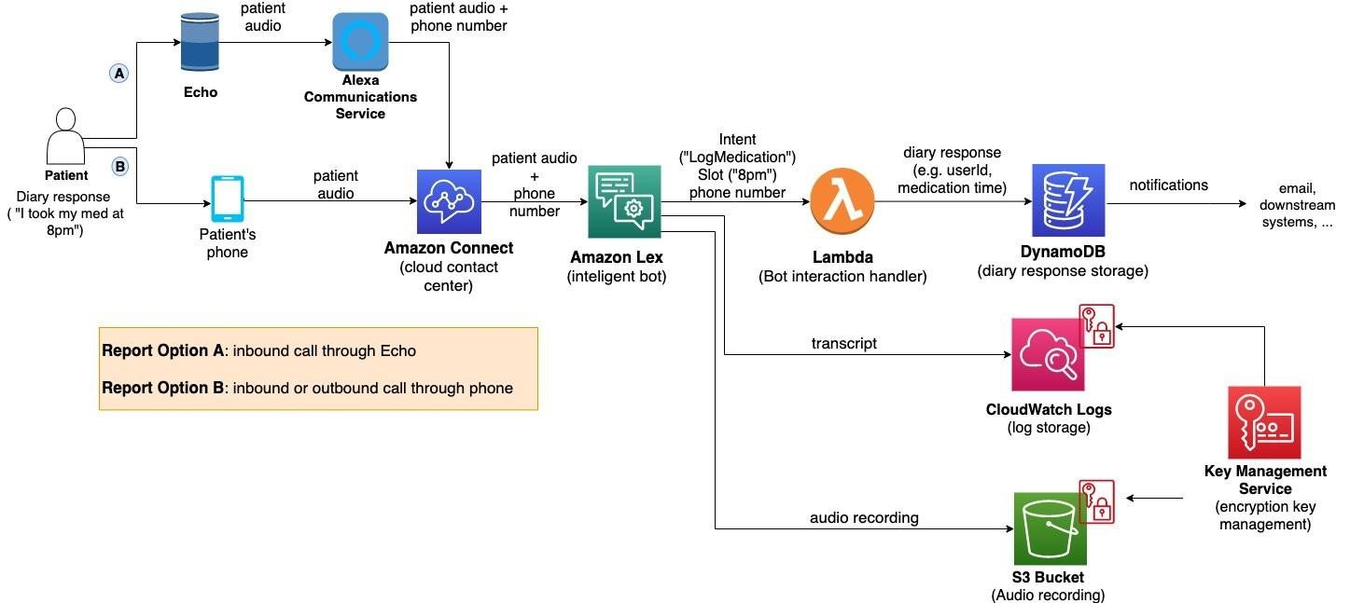

*Figure 1: Architecture and data flow of the voice patient diary sample application*